**IR SENSOR MODULE**

**What is IR Sensor Module?**

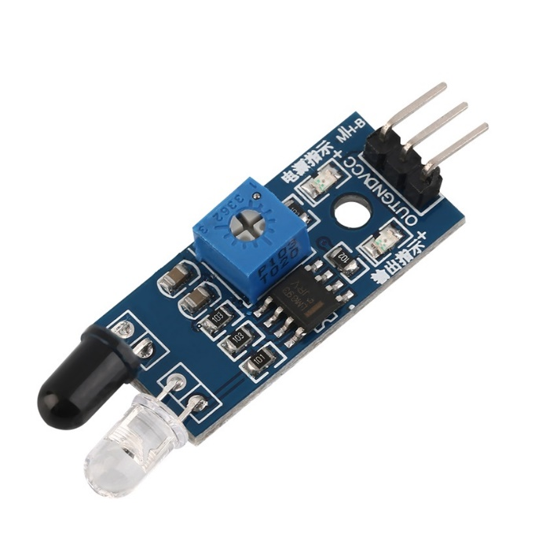IR sensor module consist of a pair of infrared transmitter and the receiver. The transmitter emits a certain frequency of light, the light reflects back if an obstacle is found which is received by the receiver, if no obstacle is found the light won’t be reflected. If an obstacle is found, the module returns 0 and if obstacle is absent, the module returns 1. Also, the distance up to which the module will check for obstacles can be set using the potentiometer on the module.

**Different Parts of IR Sensor Module**

The IR sensor module consists mainly of the IR Transmitter and Receiver, Op-Amp, Variable Resistor and output LED.

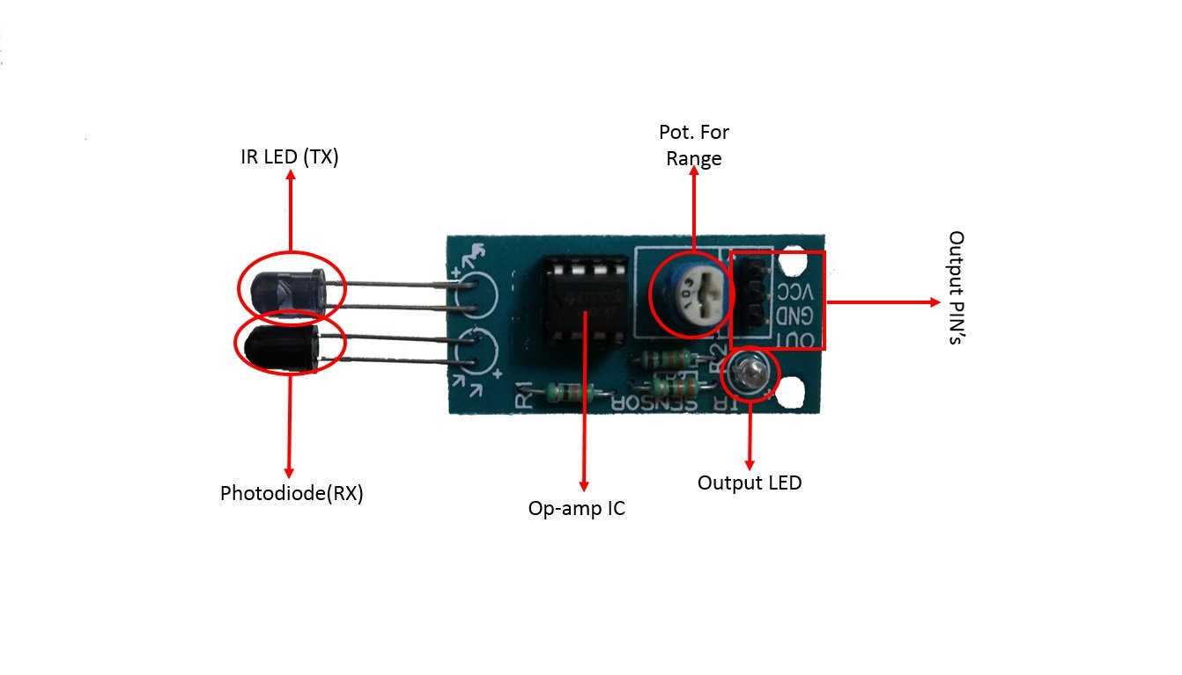

IR LED TRANSMITTER: - IR LED acts as the transmitter in the module as it emits light of frequency in infrared region which are not visible to human eye. It has light emitting angle of approx. 20-60 degree and range of approx. few centimeters.

PHOTODIODE: - Photodiode acts as the receiver as its conducts when light falls on it. The current flowing through it is directly proportional to the intensity of light falling on it.

OP-AMP: - The Op-Amp acts as a comparator circuit here, it compares the threshold voltage set by user and the voltage of photodiode’s series resistor.

If Photodiode’s series resistor voltage drop > Threshold voltage = Op-amp output is High

If Photodiode’s series resistor voltage drop < Threshold voltage = Op-amp output is Low

POTENTIOMETER: - The potentiometer is used to determine the threshold voltage. This threshold voltage decides the range of the IR Sensor Module

**How does IR Sensor Module Work?**

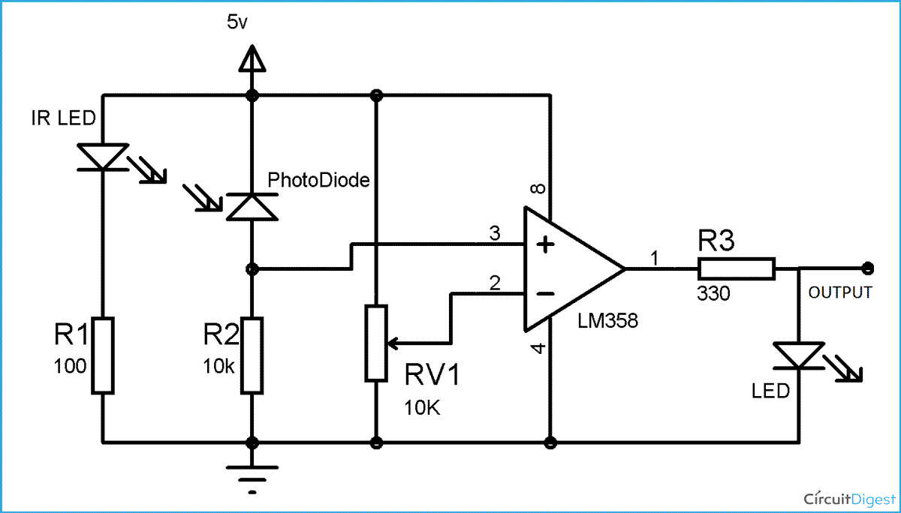

The IR LED emits light in certain direction, if an obstacle is detected in that direction, the light is reflected and the intensity of the light depends upon the distance of the object from the IR LED. The reflected light then falls upon the photodiode and it starts conducting. The current flowing through it depends upon the intensity of light falling on it. The current flowing is directly proportional to light intensity. When the photodiode conducts then a voltage appears between the photodiode and resistor. If no obstacle is detected, then no light is reflected and hence the photodiode doesn’t conduct so there exists 0V between the photodiode and resistor. Now, the voltage between the photodiode and resistor and a threshold voltage set by user is fed to Op-Amp which acts as a comparator here. If Photodiode’s and resistor voltage > Threshold voltage = Op-amp output is High. Or if Photodiode’s and resistor voltage < Threshold voltage = Op-amp output is Low. The threshold voltage is set using the potentiometer and decides the range up to which an obstacle is to be detected.

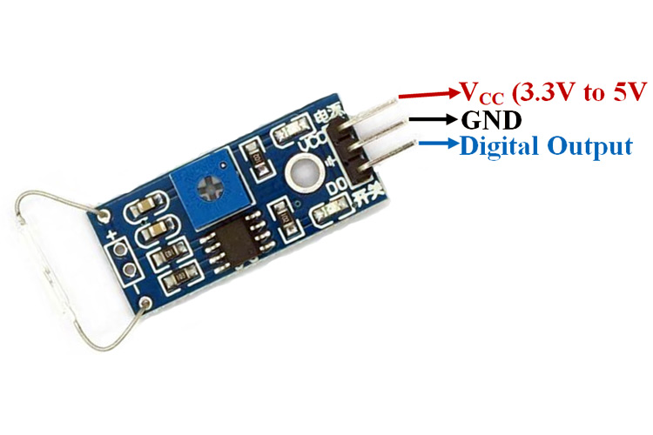**PINOUTs**

|  |  |
| --- | --- |
| **PIN NAME** | **DESCRIPTION** |
| VCC | 5V DC is supplied here. |
| GROUND | It is connected to the ground. |
| OUTPUT | It gives a digital output depending on the presence of obstacle. |

**Some More Specifications**

|  |  |
| --- | --- |
| Operating Voltage | 5V DC |
| Operating Current | 20mA |
| Range | Up to 20cm |